Room B
BQ1 Gastric Mass
Stem: 64 y/o male presents with a vague epigastric pain, decreased appetite with unintentional weight loss over 30 lb. Denies dysphagia, odynophagia, has been having normal bowel movements without hematochezia or melena.
PMH/PSH: He has no history of GERD, has never had an upper endoscopy or colonoscopy.
Social History: He previously smoked heavily, drinks EtOH weekly.
Meds: None.
Family history: Unremarkable.
Physical Exam: He is cachectic, chronically deconditioned. Abdomen is soft, nontender and without palpable masses. Rectal exam is unremarkable.
Labs: CBC/CMP (normal) , Coags (normal), Prealbumin 11/albumin 2.9.
What is your Differential Diagnosis?
- Adenocarcinoma (gastric, duodenal, pancreatic)
- Benign polyp
- Neuroendocrine tumor (NET)
- Gastrointestinal stromal tumor (GIST)
- Lymphoma (i.e MALT lymphoma)
What would you like to do now?
- EGD with EUS and FNA:
Note: EUS gives diagnostic accuracy up to 98% for gastric cancer and provides tumor and lymph node stage.
2. Upper GI study.

Scenario
EGD reveals a large exophytic gastric mass in the mid/distal antrum. Biopsies are taken and demonstrate poorly differentiated gastric adenocarcinoma. Any Further tests?

Needs staging:
- CT Chest/Abdomen and pelvis with PO/IV contrast → negative for metastatic spread.
- PET-CT is instrumental in identifying regional and distant metastases → peri gastric lymph nodes.
- Consider Staging laparoscopy.

Scenario: In different patients, If EUS shows the following T stage, what would you recommend?
- cTis: How would you remove ? EMR (Endomucosal resection)
- cT1a? EMR (Endomucosal resection)
- cT1b? Gastrectomy without neoadjuvant therapy.
- cT2? neoadjuvant chemo or chemoradiation

Who would you treat with neoadjuvant chemo or chemoradiation? cT2 or any N

How do you decide the extent of resection in gastric adenocarcinoma?
- Must have > 5 cm margin.
- Proximal tumor → total gastrectomy with EJ.
- Distal tumor → distal gastrectomy vs subtotal gastrectomy.

Tumor is distal, describe your operative approach ?
  - Distal gastrectomy with D1 Lymphadenectomy.
Consider total gastrectomy if patient has genetic predisposition (CDH1) or strong family history of Gastric CA
  - Midline laparotomy, full exploration, and appraisal of the peritoneum.
  - Mobilize the GEJ and esophagus.
  - Separate the omentum from the transverse colon.
  - Divide the short gastric arteries.
  - Skeletonize the celiac, splenic, and common hepatic arteries, and take Lymph nodes (remember must have 15 or more; minimum of D1 Dissection)
  - Ligate the left, right and gastroepiploic arteries.
  - Look out for accessory/replaced left hepatic artery arising from left gastric artery (seen in 10-15% of patients).
  - Divide stomach, esophagus and jejunum.
  - Roux en-y esophagojejunostomy and jejunojejunostomy. (may be antecolic or retrocolic).
  - Consider distal feeding jejunostomy.

Describe your decision making for extent of lymphadenectomy (LAD) in gastric adenocarcinoma?
- (must perform a minimum of D1)
a. D1: peri-gastric (stations 1-6)
b. D2 celiac axis and branches (Stations 7-11)
c. Must have at least 15 nodes and at a minimum D1 lymphadenectomy
Note: : D2 associated with improved survival in Asian studies, has not been shown to improve survival in western pts.) Reasonable to D1, D1 + as many D2 nodes as possible or D2 with or without distal panc/spleen. If you go this route must explain why.
Scenario (If time allows) : What if in the case above the EGD/biopsy demonstrates Lymphoma?

What type of Lymphoma would you expect? MALT Lymphoma
How would you manage?
- The initial treatment of MALT lymphoma is eradication of H. Pylori (treat with “triple therapy; proton pump inhibitor, clarithromycin, and amoxicillin or metronidazole for 14 days).
- Must monitor with serial endoscopies to monitor for disease response
What if medical management failed? Local radiation therapy with curative intent.

Pitfalls:
- Not knowing correct staging workup.
- Not Understanding location of tumor effect on management.
- Not knowing role of EMR.
- Should be able to discuss extent of LAD.
- Should know genetic disposition needs (CDH genes) Needs total gastrectomy.
Reference:
- https://www.gastrojournal.org/article/S0016-5085(19)41888-X/fulltext.
- https://www.cancer.gov/types/stomach/hp/stomach-treatment-pdq
- https://www.nccn.org/guidelines/category_1

BQ2 Arteriovenous Fistula with Outflow Stenosis

Stem: 58-year-old male with end stage renal disease presents to the emergency department with redness and thinning skin overlying his left brachiocephalic arteriovenous fistula. You are called to see the patient emergently because of reports from the dialysis center that they had difficulty stopping the bleeding from one of the sites after dialysis earlier today. The ER physician has outlined the areas that she is concerned with.
PMH:
ESRD, HTN, medullary cystic GN.
PSH:
Left AVF, Appendectomy as a child.
Medications:
Amlodipine, calcitriol, atorvastatin.
Physical Exam:
Temp 99.5
HR 102
RR 21
BP 185/87
GEN: Alert and oriented x3
EXT: Left AVF is very pulsatile but has a component of a thrill with an audible bruit. There are three areas of aneurysmal dilation two of which have some associated erythema (as seen in the picture).
Labs:
WBC 14K; H/H 9/27: PLT 270K
CO2 18, CR 5.7, K 4.9.
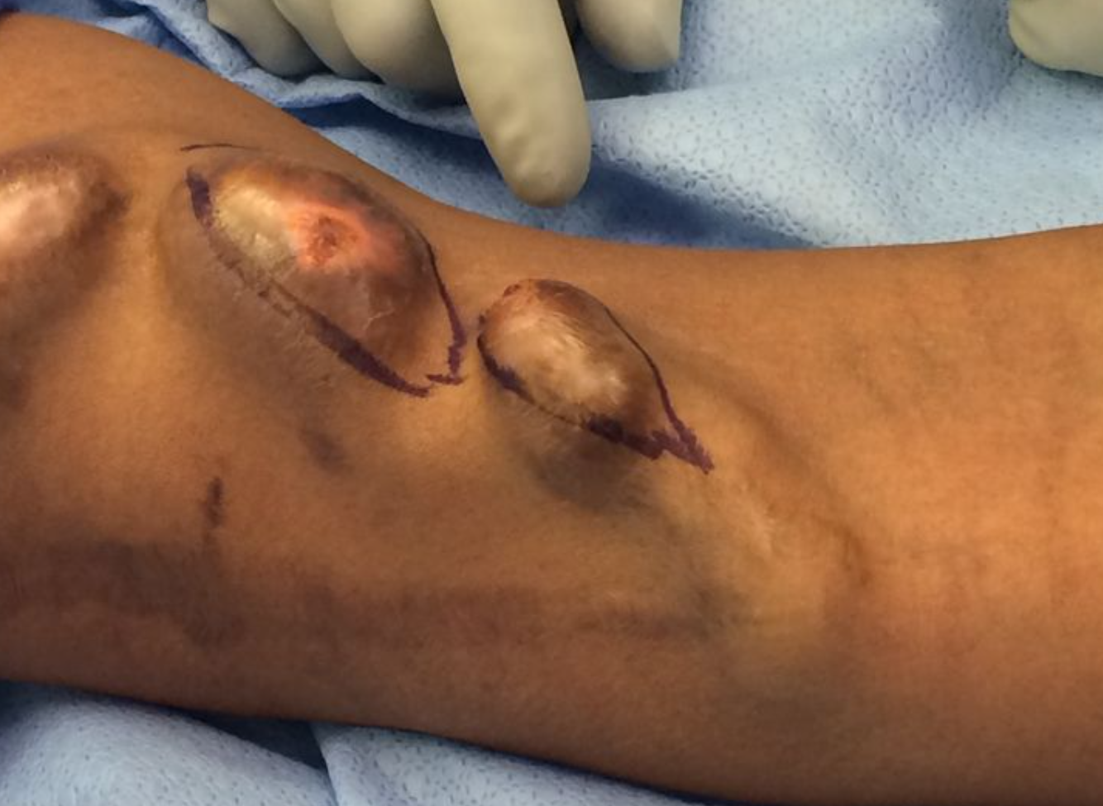
Note the scab over the puncture site and the very thin, erythematous skin.

How would you manage this patient?
- Admit the patient.
- dose of antibiotics (Ancef or Vancomycin)
- type and cross for two units of blood.
- perform a fistulogram and balloon angioplasty to alleviate the almost certain outflow stenosis.
Pitfall! If they attempt to operate on this patient without first managing the outflow: Alter the scenario such that they are then in the operating room and once they make an incision, explain that the cannulation site is now bleeding profusely with the blood hitting the ceiling. Did they place a surgical tourniquet after they prepped the arm? How will they get proximal and distal control?
- (Note: Patients with long standing, high flow arteriovenous fistulas develop outflow or central venous stenosis secondary to venous intimal hyperplasia (caused by the turbulent blood flow). Attempting surgical intervention, without first treating the outflow stenosis can lead to uncontrolled hemorrhage.)
  - place tourniquet above the area of cannulation.
  - procedure should be performed using fluoroscopy.
  - perform micropuncture cannulation of fistula.
  - exchange to 7Fr sheath over guidewire.
  - perform angiogram.
  - identify site of stenosis.

    - 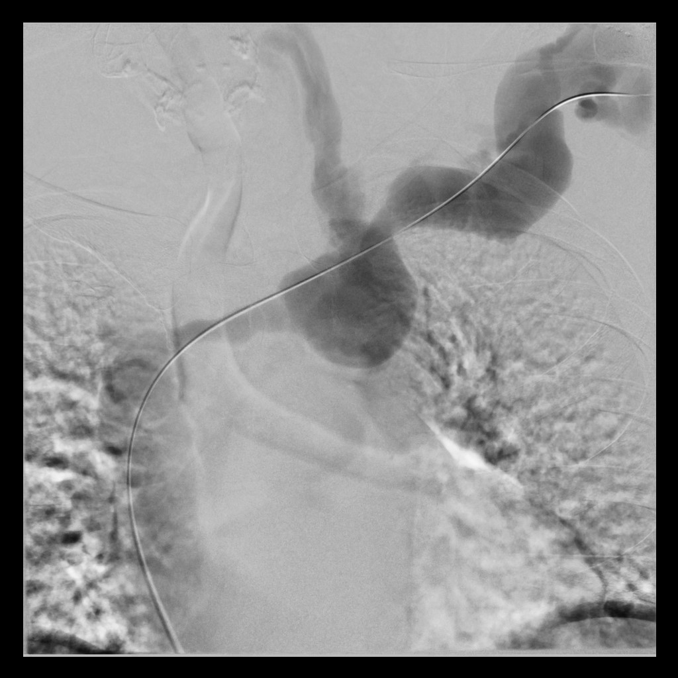
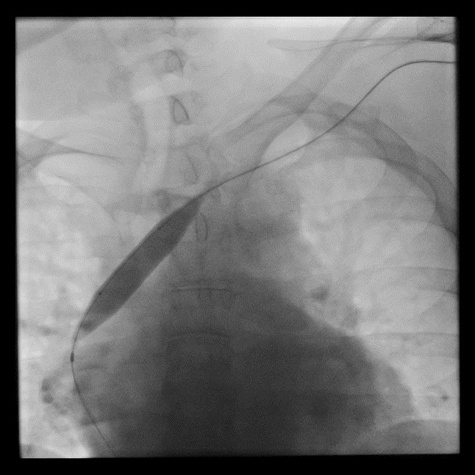
On the fistulogram, the examinee should note the contrast refluxing up the left internal jugular vein (suggesting outflow stenosis) and the narrowed innominate vein, central to the left internal jugular vein.
  - place guidewire across area of stenosis.
  - advance angioplasty balloon over guidewire.
  - perform balloon angioplasty.
  - perform completion angiogram.
  - Once the outflow stenosis has been treated, excise aneurysmal section.
    - excise the anterior wall of aneurysmal sections.
    - repair the fistula wall primarily (2 layers - running horizontal mattress followed by an anterior running simple layer; 3-0 or 4-0 prolene suture).
    - The subcutaneous tissue and the skin should be closed over the top.
    - Some may opt to do a bypass of this area with a PTFE or bovine graft and this is an acceptable surgical option.

Pitfalls:
- Not performing fistulogram before proceeding to OR.
- Not Using torniquet.
- Trying to put stitch in ER in the weak point of the AVF.

Reference:
- https://www.ncbi.nlm.nih.gov/pmc/articles/PMC4515897/

BQ3 Pediatric Esophageal Burn
Stem: You are called to the ED to see an 8-year-old child that accidentally drank strong alkali solution. Otherwise, previously healthy.
(Background to note: Alkali is more destructive than acids, producing liquefactive necrosis which almost ensures deep penetration. Liquid alkali (as opposed to solid) allows contact to the esophagus and stomach with concomitant damage, which can extend to the adjacent structures. Reflex antral and pyloric spasm cause the alkali to pool in the stomach and reflux into the esophagus. This may cause relatively little oropharyngeal burn and still have severe injury to the esophagus and stomach)
What would you want to do now in the ED?
1. Airway: Look for stridor and hoarseness. - oral intubation is indicated if there is laryngeal edema or laryngeal destruction from ingestion.
2. Breathing – supplemental 02
3. Circulation - IV fluids should be instituted to correct hypovolemia. Keep NPO
4. Antibiotics - broad spectrum antibiotics should be started ASAP to diminish risk of aspiration as well as direct bacterial invasion through the damaged wall of the esophagus.
5. Steroids - NO. Have been advocated to prevent stricture but efficacy has not been established. May also mask sepsis and injury while slowing healing.
What would you like to do for workup?
- Chest XR. Why? Looking for abdominal free air or pleural effusion.
- Abdominal XR. Looking for free air or pleural effusion.
- Contrast Esophagram- This is the best way to evaluate an esophageal perforation.

What contrast to use?
- Use water-soluble gastrograffin.
- Diluted barium should be used if perforation is suspected and not seen with initial water-soluble contrast esophagram.
- Esophagoscopy-
  - Describe: Should be used ASAP after admission to establish diagnosis and grade the severity of the injury.
  - Should use pediatric flexible endoscope.
  - Sedation to minimize the risk of perforation.
  - It is acceptable to advance the scope past the area of the first burn, though conservative answer is to pass the scope to the level of the first burn.

How would you grade?
- First degree: mucosal hyperemia and edema.
- Second degree: mucosal ulceration with vesicles and exudates, pseudomembranes present.
- Third degree: deep ulceration with charring and eschar formation→severe edema obliterating the lumen
What is your treatment for ?...
1. First degree: No specific treatment for 24-48 hrs. May begin liquids and treated as an outpatient
2. Second degree/third degree: Closely observed for evidence of gastric or esophageal perforation during the acute phase of injury.
What if your work up is not showing free air but patient is with persistent back pain?
- Expect mediastinitis, peritonitis, should be explored.
Describe your operative steps?
- Prep the neck, chest, abdomen to axillary lines.
- Abdominal approach.
- If an esophageal resection is needed, a trans hiatal esophagectomy should be performed.
- Don't reconnect if done emergently. Delay reconstruction for several months. (Gastric conduit or colonic interposition only if totally stable and perfect).

Second- and third-degree burns will cause stricture formation, when would you dilate?
- Wait 6-8 weeks for dilation to allow re-epithelialization to take place and decrease risk of perforation.
Describe?
- Series of dilations for 2-3 weeks. Goal is for 46 Fr. or larger for adults & a 32-40 Fr. dilator for a 2- 3 yr. old child.

Pitfalls:
- Not knowing steps for workup.
- Not knowing when to use barium and to dilute.
- Not knowing indications for operative management.
- Not knowing when to connect and timing of conduit.
- Not knowing management of stricture.

Reference: https://www.nejm.org/doi/10.1056/NEJMra1810769.

